DILLA UNIVERSITY


DIRECTORATE OF LIBRARY AND INFORMATION SERVICES

LIBRARY AND INFORMATION SERVICE MANUAL

Dilla, Ethiopia
February 2025
Table of Contents
CHAPTER ONE 3
1.1 Introduction 3
1.2 Motto 4
1.3 Vision 4
1.4 Mission 4
1.5 Objective 4
1.6 Definition of terms 4
1.7 Members 5
1.8 Basic provisions of the Manual 6
1.9 Library opening hours 6
CHAPTER TWO 6
2.1 Branch Library 6
2.2 Rights and Responsibility of users 7
2.2.1 Rights of Library Users 7
2.2.2 Responsibility of Library Users 7
2.3 Violations of various library laws and regulations and corresponding penalties 8
2.3.1 Low Level Penalty 8
2.3.2. Medium Level Penalty 9
2.3.3 High Level of Penalty 9
2.4 Library sections and activities 9
2.4.1 Photocopy and Binding Sections 9
2.4.2 Reference room Section 10
2.4.3 Documentation and Periodical Section 11
2.4.4 Technical Processing Sections 11
2.4.5 Loan Section Activities 12
2.4.6 Circulation section 16
2.4.7 Check point (Library Attendant) 17
2.4.8 Temporary ID Card 18
2.4.9 Shelving Section 18
2.4.10 Clearance 18
2.4.11 E-Library section 19
CHAPTER THREE 29
3.1 Library Employee Ethics and Member Complaint Management 29
3.1.1 Library Employee Responsibilities 29
3.1.2 Library Employee Right 29
3.2 Employees Disciplinary Measures 30
I. Light Disciplinary Measures 30
II. Heavy Disciplinary Measures 31
3.3 Ways of Member Complaint Management 32
CHAPTER FOUR 32
4.1 OTHER CONCERNS 32
4.2 Book Store 32
4.3 Library usage hours 33
4.4 Amendment of the law and its implementation period 33

CHAPTER ONE

1.1 Introduction
Dilla University Library and Information Service was established in 1996 (1987 E.C.) with limited resources, including minimal materials, facilities, and staff. Since its inception, the library has played a vital role in supporting the university’s core academic mission by facilitating teaching, learning, and research activities.
Operating under the Vice President for Academic Affairs, the library has expanded its services over the years to meet the growing needs of students, faculty, and researchers. It currently provides both traditional and technology-driven library services, including a manual system, digital library services, and an institutional repository to enhance access to academic resources.

1.2 Motto
Empowering Knowledge, Enriching Minds, Advancing Excellence.

1.3 Vision
To contribute the academic and scholarly excellence of the university by providing world-class information resources, facilities, and innovative services that will advance teaching, learning, and research.

1.4 Mission
To foster intellectual growth, academic success, and lifelong learning for the students and staff of the university.
To achieve this mission Library provides 7 days per week for 24-hour services for its users.

1.5 Objective
- To select and find information that is useful to the university and to ensure that it is used carefully and appropriately.
- To provide timely information to users.
- To collect books, journals and other information that meet the quality and standard in organizing books and to organize them in a way that is convenient for the user.
- To make any information (books, journals and others) available in the library accessible to all users in an appropriate manner and to control its management.

1.6 Definition of terms
- “Reference books” are a type of book that is read in libraries and is not taken out of the library, either by loan or otherwise.
- “Library attendant” is a library employee who checks in and out of the library.
- “The Director of Library and Information Services” is the person who manages the overall operations and services of the library.
- “Circulation Service” means a section where books and other services are provided to users.
- “Internal users” means users who are employees of Dilla University.
- “Library and Documentation Service” means the Library and Documentation Service of Dilla University.
- “A pocket” is a legal card that allows you to use and borrow library services.
- The “university” means Dilla University.
- “Users” means individuals who use the library services.
- “E-library” means books and various printed materials, audio information, software and various documents available electronically.
- “Reserve books” are a limited number of various books and information resources that are made available to users through the circulation desk.
- “Library staff” means a person who works at a library.
- “Academic staff” are university employees engaged in teaching and research and employed in a manner approved by the University.
- “Administrative staff” means university employees who are not directly involved in teaching and learning.

1.7 Members
The following are eligible to become members of the library:
- University Academic staff
- University administration staff
- University students
In addition, Eligibility Criteria for Library Membership:
- New students entering the university must attend the orientation given about the library.
- A new student who does not attend the orientation given at the beginning of the year cannot become a member of the library.
- A student who applies to become a member of the library must have a renewed university ID.
- A newly hired faculty or administrative staff member can become a member of the library if he/she has an ID showing that he/she is a university employee.
- A newly hired faculty or administrative staff member who does not have an ID showing that he/she is a university employee or has not been issued one, can become a member of the library if he/she brings a letter from the department stating that he/she is an employee.

1.8 Basic provisions of the Manual
The rules and regulations have been prepared to ensure that students, faculty, and support staff at the university can use the information available in the libraries appropriately. These rules and regulations apply to all libraries at the university. In addition to these rules and regulations, users are required to comply with other rules and regulations at the university.

1.9 Library opening hours
The library provides services at the following times:
- Morning: 2:00 AM – 7:30 AM
- Afternoon: 7:30 AM – 1:00 PM
- Night: 6:00 PM – 11:30 PM
- Midnight: 1:00 AM – 6:00 AM
- The university Book store is open during working hours from Monday to Friday.

CHAPTER TWO

2.1 Branch Library
Library Branches at Dilla University
Dilla University has multiple library branches that serve different faculties, departments, and academic needs. Each branch provides specialized resources and services to support teaching, learning, and research.
Figure 2: 1 Branch Library and Locations
No | Name of Library | Location
1 | Engineering Library | Odaya'a Campus
2 | Natural Science Library | Old Campus.
3 | Freshman Library | Old Campus
4 | Social science Library | Odaya'a Campus
5 | Law Library | Odaya'a Campus
6 | Institute of Behavioral Library | Odaya'a Campus
7 | Health Science Library | Referral Hospital Campus
8 | Business and Economics Library | Hasedela Campus
9 | Gender Library | At all Campus

2.2 Rights and Responsibility of users

2.2.1 Rights of Library Users
- Users have full rights to use any library services reserved for them.
- Users have the right to fair and inclusive services.
- A user can bring a textbook borrowed from the library book store into the library and read it.
- Users have the right to bring their own personal books and read them.
- Users can borrow materials according to the library's lending policies, with a reasonable period for returning them and the ability to request renewals.
- Users have the right to access the library's resources, including books, journals, e-books, databases, and other materials available for use.

2.2.2 Responsibility of Library Users
- Members must show their ID when asked to do so at the entrance to the library.
- When entering the library, personal belongings such as books, large bags, umbrellas, etc. are not allowed. However, users may leave their personal belongings at the property deposit table located near the library entrance.
- Any user is strictly prohibited from entering the library with a fake ID using another person's name and address.
- Sleeping in the library is prohibited.
- Any user is prohibited from damaging books and non-book-related assets in the library and from writing unnecessary texts on the assets.
- Smoking, wearing loud shoes, talking loudly, moving chairs and tables, and bringing in food and drink are strictly prohibited.
- Wearing a scarf, a hat, a work coat, a coat with a hood, and open-toed shoes that make noise are not allowed in the library.
- A user who does not fulfill with the above rules and regulations will not be allowed to enter the library or borrow books from the library.

2.3 Violations of various library laws and regulations and corresponding penalties
The levels of violations and their corresponding penalties, which occur during service provision, whether knowingly or unknowingly, from the various rules and regulations of the service department that are visible to the user, are set out below.

Low Level Penalty
- A user entering the library wearing a scarf, towel, or hat (does not include religious attire for Muslim female students).
- Making unnecessary and disturbing noises after entering the library.
- Placing notebooks and books to save space, group and joint discussions and studies.
- Found taking photos and recording videos without the library's permission.
- Posting advertisements, speaking without the library's permission.
- Users who do not just throw shredded papers in the trash bin and do their part to keep the library clean.
- Taking reference books from where they are kept, running away, or hiding them.
- User found using outside of the allowed reading area.

2.3.1.1 A punishment appropriate with the minimum level of penalty
A user who is found to have violated the above rules from letters A to H, based on the information recorded by the nearest shift coordinator or a librarian, will be suspended from any library service for three consecutive days after the initial warning and reprimand.

2.3.2. Medium Level Penalty
- Any user found writing on library property with a pen and pencil.
- A user caught listening to or watching sexual visual content, including music, on a tape recorder, earphones, or any other electronic device within the library
- A user who is found talking on the phone in the library. Also, a user who does not put their phone on silent mode or turn it off when entering the library.
- A user who enters or has entered the circulation room, other than library staff.
- A user who has taken someone else's ID or pocketbook, received an ID on behalf of another user, or has been found using another person's ID.
- A user tried to use the same ID.

2.3.2.1 Punishment corresponding to the Medium level of offense
A user who has violated the low level of penalty listed in 2.3.1 above, from A to H, more than twice, and who has violated the medium level of penalty listed in 2.3.2, from A to F, will be banned from any library service for two weeks if the violation is recorded by a registered professional or the head of the library.

2.3.3 High Level of Penalty
- A user was caught cutting parts of books.
- A user who enters the library with any weapon, for example (a knife).
- A user who insults and belittles a library employee in a way that undermines their dignity and identity.
- A user who disrespects the library and the university.

2.3.3.1 Punishment corresponding to the High level of offense
A user who has violated the medium level of violation listed in 2.3.2 above, from A to F, more than twice, and who has violated the letters A to D in 2.3.3, if the violation is recorded and confirmed by the library team leader and the directorate, the case will be considered and necessary action will be taken in accordance with the relevant university disciplinary law.

Library sections and activities

2.4.1 Photocopy and Binding Sections
- Photocopy
Photocopying services are available to users by copying and reserving the required books for the library. If the library is unable to provide the service, students and teachers can bring their ID cards to the relevant circulation or reference desk. They can then have the book photocopied within one hour (1:00) at the designated photocopying service outside the library.
Note: If the user does not return the books taken out for photocopying service within the allotted time, he/she will be charged a fine of 0.50 cents per minute for the amount of time he/she has overstayed.
- Photocopy Charges/Reproduction
  - Pages may be copied form library resources & are to be paid for the service.
      - Br 2.00 for students and staff
- Users are responsible for observing copyright regulations, if available.
NOTE: please ask pay receipt after the service.
- Binding
The library offers binding services to ensure the durability and preservation of books, research materials, and other important documents. The key activities include:
- Book Repair and Reinforcement
- Repairing damaged book covers and pages.
- Reinforcing weak or torn bindings to extend the lifespan of library materials.
- Official Document Binding
- Binding administrative documents, reports, and archives for proper storage and reference.

2.4.2 Reference room Section
These are collection used for ready reference or quick information. Technically they are not meant from page to page reading. These kinds of information can also be served by the reference librarian.
- Any ready reference sources, such as Encyclopedias, Dictionaries, Handbooks etc. are organized in special area in the library labeled with a mark “REF” in the spine of each material & arranged sequentially by call number.
- Are managed & administered by reference section staffs.
- Reference materials are not allowed, by any means, to be checked out from the library.
- Unless it is decided to be a reserve for spot reading reference resources are open for access to the users directly.
- Closed access reference items are borrowed by ID card from reference desk librarian. These items loan period is same as Reserve items (i.e. an hour).
- They could also be in electronic format.

2.4.3 Documentation and Periodical Section
- Documentation
These are information resources which include government, NGO, notable personalities note, standards, senior essays, thesis, dissertations, etc..
- It has closed access system (Access procedure is the as Reference Items).
- Managed & administered by Documentation staffs.
- Those items which belong to these categories are not allowed out of the library use.
Note: in this section only, staff members and graduating degree students can have an access and the materials are not checked out for overnight.
- Periodical
These are items that appear periodically in regular basis in sequence with volume & issue number.
- They range from subject (professional) journals to Newspaper & magazine.
- Managed & administered by periodicals section staffs.
- Shelved alphabetically by Title.
- Those items which belong to these categories are not allowed out of the library use.

Technical Processing Sections
- Acquisition and Cataloging Activities
To approve the book selection policy, select books, request and prepare the library budget, place purchase orders, receive new books, catalog them upon arrival, create a card catalog or digital catalog, and ensure public access to the collection.
- Classification Section Activities
To classify all information resources using the DDC classification system, assign book numbers and book labels, prepare a shelf guide list, and arrange books on the shelves according to the classification plan, etc.

2.4.5 Loan Section Activities
The majority of library resources (printed & electronic) is available for loan and can be borrowed by eligible users except those materials that are not normally loaned.
Generally, for those materials that can be loaned, the loan service is of three types:
      - Short Term Loan
      - Long Term Loan and
      - Interlibrary Loan
- Short Term Loan
This is the service for which materials; especially those reserved are borrowed for spot (i.e. for an hour) reading only. Except a 24 hrs loan in a week for circulation desk library staffs, who are attending formal education at tertiary level based on the arrangement made by campus library team leaders.
Procedures for spot reading:
Issuing (check-out)
- The borrower must deposit her/his valid I.D card until she/he returns the material.
- The user should write the date, I.D. number and the time of return (usually an hour) in the reserve item card. After checking the reserve item card filled by the borrower, give the material to the user.
- Clip the I.D. card and the material card together.
- Put the clipped I.D. card together with the item card in the borrowers file around the circulation desk arranged by author name.

Receiving (check-in)
- Pull out the readers I.D. card & the material card from the borrowers file.
- Check carefully that the material being returned is the same as that is shown in the material card.
- Check for the time in return in the item card.
  - If it is over fine the user based on the law of the library.
- Detach the I.D from the item card.
- Return the I.D. to the borrower.
- Place the item card in to the item.
- Shelf the item to its appropriate place.
- Long Term Loan
A long-term loan is a loan which will be given at circulation desk for specified date or month(s).
This service is a type of loan service that allows students, administrative staff, and academic staff to borrow books for extended periods based on membership cards. It is available during regular hours and is governed by additional relevant regulations
Procedures
Issuing (check-out)
- The borrower should present her/his valid library pockets for each item she/he wants to borrower.
- Check the borrower’s library pocket matching with her/his valid I.D. Card.
- Check borrowers personal/fine file
- If the user has lost a library material & not paid she/he should not be served.
- The reader is requested to fine if she/he owes the libraries any overdue.
- If the cases are there she/he should first pay fines.
- Pull out the stack loan card from the item's pocket.
- Check the bibliographic information, especially of the accession/copy number in the item card is coincides with the right item.
- Place the item's card in the borrower’s pocket.
- Stamp the date of return on both item card & the date due sheet on the item or if it is stack-spot-reading item you are not required to stamp date due & one pocket can be used for more than one item.
- Give the item to the borrower.
- File the pocket attached with item card in the borrowers file arranged by call number.
Receiving (check-in)
This is the service for which library materials checked-out for a given time period can be returned.
The procedure for returning is: -
- Pull out the card clipped with the borrower’s pocket from the borrowers file & from the pocket.
- Check carefully that, especially that of the accession number & copy number of the book being returned is the same as shown in the book card.
- Check the due date stamped.
  - If the date returned is over from the date stamped, the user has to pay the overdue before the pocket is returned.
  - Fill the necessary information on overdue slip in two copies & provide one copy to the user & keep one copy with the pocket in the fines file until she/he came back with pay receipt.
- Return the pocket to the user.
- Return the item on shelves appropriately.
NOTE:
- Prepare overdue list for unreturned items timely.
- Send/post the remainder or overdue notices to borrowers by their address timely and on library notice board. If the clients don’t return the material after reminding notices, he might not get any services.
Procedure for reminding notice
  - Date due is over is more than 2 days,
  - Required to be reserved,
  - The library is going to conduct inventory,
  - The item is decided to be weeded,
  - The item is required for binding,
  - The item is requested to be borrowed by another user, &
  - Other decisions made by the library.
- A book may be renewed twice unless another user required it.
- The user can renew the material either on the circulation desk, by telephone or E-mail.
- Overdue books can't be renewed unless the fines have been paid.
- Interlibrary Loan
Interlibrary loan is the service provided by the library by the request of user.
- Pockets Allowed for library members
All library members are required to have membership cards, which will be issued and renewed at the start of each academic year.
No | User Type | Number of pockets
1 | Professors | 10
2 | Associate professors | 10
3 | Assistant professors | 10
4 | Lecturers | 8
5 | Assistance lecturers | 8
6 | Graduate Assistance | 5
7 | Technical Assistance | 3
8 | Lab Attendants | 2
9 | Post Graduate students | 3
10 | Undergraduate students 1st | 2
11 | Administrative staff | 2
12 | Regular students 2-3rd year | 2
13 | Regular students 4 year and above | 3
14 | All summer students 2nd year and above | 3
15 | All CEP IV Semester and above | 3

- Loan Periods
No | Items | Prof. | Assoc. Prof | Asst. Prof | Lect | Asst. Lect | Grad. Asst | Techn Asst | Lab Attendant | PG Stud. | Graduating Class Stud | Undergraduate students
1 | Books from stacks | 1hrs-1month | 1hrs-1month | 1hrs-1month | 1hrs-1month | 1hrs-1month | 1hrs-1month | 1hrs-1month | 1hrs-15 days | 1hrs-15 days | 1hrs-15 days | 1hrs-15 days
2 | Reference books | 0 | 0 | 0 | 0 | 0 | 0 | 0 | 0 | 0 | 0 | 0
3 | CD-ROMs | 1hrs-1month | 1hrs-1month | 1hrs-1month | 1hrs-1month | 1hrs-1month | 1hrs-1month | 1hrs-1month | 1hrs-15 days | 1hrs-15 days | 1hrs-15 days | 1hrs-15 days
4 | Periodicals | 0 | 0 | 0 | 0 | 0 | 0 | 0 | 0 | 0 | 0 | 0
5 | Rare Books | 0 | 0 | 0 | 0 | 0 | 0 | 0 | 0 | 0 | 0 | 0
6 | Theses | 1hrs | 1hrs | 1hrs | 1hrs | 1hrs | 1hrs | 1hrs | 1hrs | 1hrs | 1hrs | 1hrs
7 | Honors Papers | 1hrs | 1hrs | 1hrs | 1hrs | 1hrs | 1hrs | 1hrs | 1hrs | 1hrs | 1hrs | 1hrs
8 | Reserve books | 0 | 0 | 0 | 0 | 0 | 0 | 0 | 0 | 0 | 0 | 0

2.4.6 Circulation section
The circulation section as its name indicates, circulates library materials between readers. Its activity, in general, consists of getting materials needed, issuing to the readers and receiving it, shelving and reserving books.
To access this service, users must follow the procedures outlined below.
- Users must present a valid ID card to the circulation staff when requesting books.
- Users should know the title or author of the book they wish to borrow. If they are unsure of either, they can use the mini-catalogue provided by the circulation section, which lists the reserved books available at the circulation desk.
- When books are requested to be serviced by a specific time, the circulation staff should first search the catalog to identify the required books, which will make their work more efficient and faster.
- The circulation staff will remove the book card from the book and keep it with the user's ID card before handing the book to the user.
- After reading, users can retrieve their ID card once the borrowed material is returned.
- Books may be borrowed for one hour and can be renewed every hour, provided there are no other users waiting
- If a borrower returns a book after the due date, their ID card will be retained, and they will be charged according to the library’s regulations.
- Penalties related to loan services
When users borrow and read for an hour in the library:
- A user who spends 20 to 30 minutes will be banned from using the library for one day.
- A user who spends between 30 minutes and 1 hour will be banned from using the library for four days.
- A user who spends more than one hour in the library will be banned from the library for one week.
- If a user does not pay the fine, their pocket (membership card) will not be refunded.
- The user must return the book borrowed for reading in the library 15 (fifteen) minutes before the library closes.
- A user who does not return a packet will not be given a clearance.
- If the user loses the borrowed book and brings back an identical copy of the book, they will be charged Birr 30.00 for technical work.
- The offender will be prohibited from accessing any library services until they have completed their sentence.
- If the user is more than one month (30 days) past the due date for returning the borrowed book, it will be considered lost and the book will be charged three times the price.

2.4.7 Check point (Library Attendant)
This is the place where library users are checked during: -
- Entrance whether they are eligible user or not, &
- The materials checked-out from the library are according to the law or not.
- There are always one guards at the checkpoint.
- Those who assigned to the checkpoint are required to check the I.D. cards of all incoming users to identify, whether they are eligible or not.
- They should also examine physically all materials, briefcases, bags, etc carried by & body of the outgoing user by circulation library assistant & the library staff by security guard.
- For a material believed to be the property of DU Libraries and date due over or not implied due date should not be released. It would be referred to the library circulation shift coordinator. or campus branch library team leader (before this process she/ he should take note of the necessary information about the item & the person under check - i.e. call number, accession number, name of the user, ID number, etc.)
- When such cases are identified the responsible staff should check the item against the necessary document & the appropriate measure should be taken.
NB: - check point library assistant must report such cases in full formally.

2.4.8 Temporary ID Card
This service is provided, if the user is:
- External member to the library system.
- Missed her/his ID card & till replaced.
Note: This temporary ID card is only for library access

2.4.9 Shelving Section
Shelving is the process of returning materials to their proper place on the shelf.
Procedure:
- All items checked in should be shelved daily,
  - 5 minutes before the closing of working hours for stack.
  - 5 minutes before shift exchange.
- As soon as possible the responsible library assistant should go around & collect the materials that are returned by readers from the receiving area.
- Arrange the books in order by
  - Call number of items, &
  - Alphabetically by author.
- Make sure that the call number, the accession number & copy number on the item card matches exactly with the item pocket.
- Return each item to its proper place on the shelf.
- For, miss shelved items are a lost item, accuracy is more important during shelving.
- The responsible assistants should take shelf reading always.

2.4.10 Clearance
All users during clearance are required to return their library pockets to the corresponding library they received their pockets.
Procedure
- During clearance check all the necessary information that is found on the pocket if it fits exactly with the information on the membership card (specially check strictly the pocket accession number of the pocket).
- Any information on the pocket that was deleted, overwritten, erased, unread or that creates vagueness is invalid.
- If there are missed or invalid pocket(s) the user is required to confirm whether her/his pocket is/are not in use in other branch libraries of DU.
- A user who is in charge of violating the rules & regulation of the library system must not be cleared by any part of the library system (including the book store) unless & otherwise she/he could come-up with the appropriate official document that has reference number, date, sign & seal of the legally authorized & mandated body of DU. The official document should incorporate what measure(s) has been taken upon the user who violated the library systems rules & regulations.
- Clearance signage for those applicants who lost their ID card at any time should come to their host branch library after clear remark of each system of DU Libraries.

2.4.11 E-Library section
At Dilla University, the ICT-Based Library Services in the E-Library section consist of two main components:
- Digital Library
- Institutional Repository
- Digital Library
Eligibility Criteria for Digital Library Membership
- Students – Enrolled undergraduate and postgraduate students of Dilla University.
- Faculty Members – Professors, lecturers, and academic staff of the university.
- Administrative Staff – Employees working in the university’s.
- Researchers – Scholars affiliated with Dilla University who require access to digital resources
General Digital Library Room Rule and Regulation
- Silence shall be strictly observed in the Digital library room.
- Users must show their ID Card when they are asked in the library.
- Digital Library is to be used for academic/Research purposes only.
- Playing games on computers is strictly prohibited in the entire Library premises.
- A user shall not give a false name and address for the purpose of entering any part of the library or getting any privilege there from.
- Sleeping is strictly prohibited.
- Online Chatting in the Digital Library is not allowed.
- Changing the settings and display of the Computers kept in the Digital Library is not permitted.
- Please handle computer, hardware, software and its accessories carefully.
- Digital Library is to be used for academic purposes only
- Each user at a stretch is allowed only for one hour for computer use in Digital Library.
- Use of secondary storage devices are not allowed without prior permission.
- Do not change any of the computer configurations.
- Do not bring any personal computer gadget inside the Digital Library.
- In case of any computer operational or access problem, report to the lab assistant.
- Access to any social media and online chatting etc. are not allowed in the Digital Library
- Respect the privacy of others by not accessing their accounts or personal information.
- Violating library rules may result in suspension of digital library privileges.
Serious offenses, such as damaging equipment or illegal activities, may lead to further disciplinary action.

1. Low-Level Penalty
- Violations:
  - Not observing silence in the digital library.
  - Sleeping inside the digital library.
  - Failure to show an ID card when asked.
  - Changing computer settings or display.
  - Mishandling computer hardware, software, or accessories.
- Punishments:
  - First offense: Verbal or written warning.
  - A user who is found to have violated the above rules from letters A to E, based on the information recorded by the digital library attendant, will be suspended from any digital library service for three consecutive days after the initial warning and reprimand.

2. Medium-Level Penalty (Suspension & Restriction of Access)
- Violations:
  - Using the Digital Library for non-academic purposes.
  - Online chatting or accessing social media.
  - Playing games on library computers.
  - Bringing personal computer gadgets inside the library.
  - Using secondary storage devices without permission.
  - Attempting to modify computer configurations.
  - Staying beyond the allowed one-hour usage limit.
  - Providing false information to gain access.
- Punishments:
  - First offense: Written warning + 1-week suspension from the digital library.
  - A user who has violated the low level of penalty listed in above, from A to E, more than twice, and who has violated the medium level of penalty listed in 2, from A to H, Written warning + 1-week suspension from the digital library.

3. High-Level Penalty (Permanent Ban & Disciplinary Action)
- Violations:
  - Accessing another user's account or personal information.
  - Unauthorized access to restricted content or systems.
  - Deliberately damaging or tampering with computer hardware/software.
  - Any form of hacking or data breach attempt.
  - Repeated violation of digital library rules after multiple warnings.
- Punishments:
  - First offense: Suspension for 1-3 months.
  - A user who has violated the medium level of violation listed in 2, above, from A to H, more than twice, and who has violated the letters A to E in 3, if the violation is recorded and confirmed by the library ICT team and the directorate, the case will be considered and necessary action will be taken in accordance with the relevant university disciplinary law.
- How to use Digital Library
To access the digital library, ensure that your device meets the following requirements:
- Device: PC, laptop, tablet, or smartphone
- Browser: Google Chrome, Firefox, or Safari (latest versions)
- Internet Connection: Stable connection required for browsing and downloading books


To accessing Dilla university digital library! Follow the steps below to easily access a vast collection of books, journals, and resources available to you:
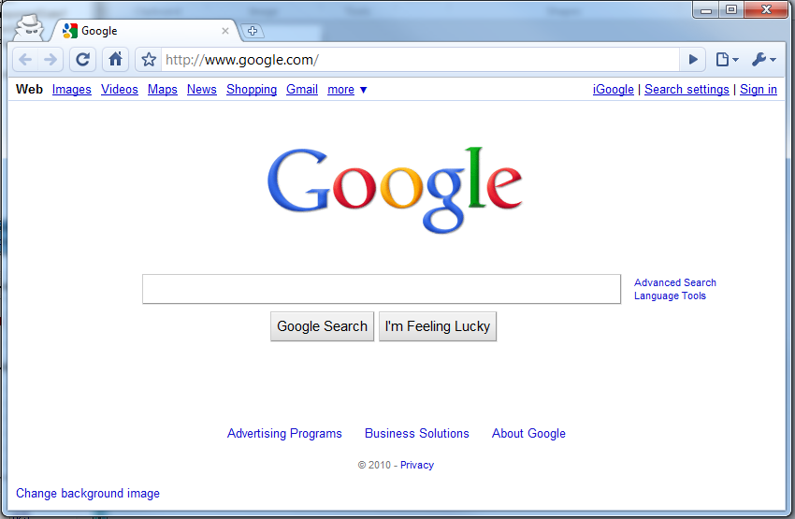
- Open a web browser.
- Enter the Digital library URL: [http://10.221.6.254:8080/digitals/]

- User Interface Overview
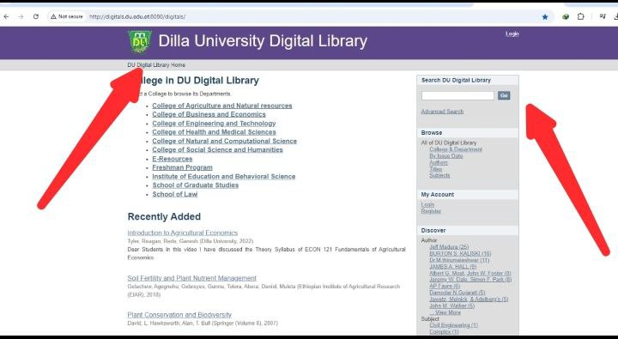
- Home Screen Layout

- Menu and Navigation Bars in a Digital Library
The menu and navigation bars in a digital library are critical tools for enhancing the user experience, making it easy to access various features, tools, and resources within the library system. Here's an overview of what end users can typically expect and how to make the most of them:
- Main Navigation Bar
The main navigation bar is the primary tool to access different sections of the digital library. Positioned at the top of the webpage or along the side, it often includes links to:

Home Icon:
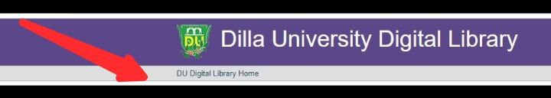
- Function: Takes users to the main or landing page of the digital library. It usually provides an overview of featured collections, recent additions, or updates.
Search Icon:
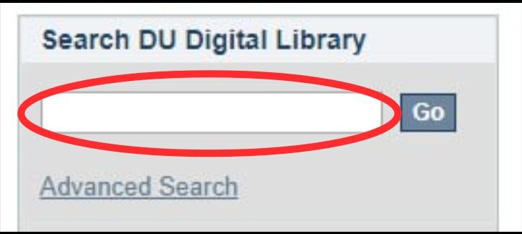
- Function: Opens a search bar or search page where users can enter keywords, titles, authors, or other criteria to find specific books, articles, or resources within the library.
Colleges Icon:
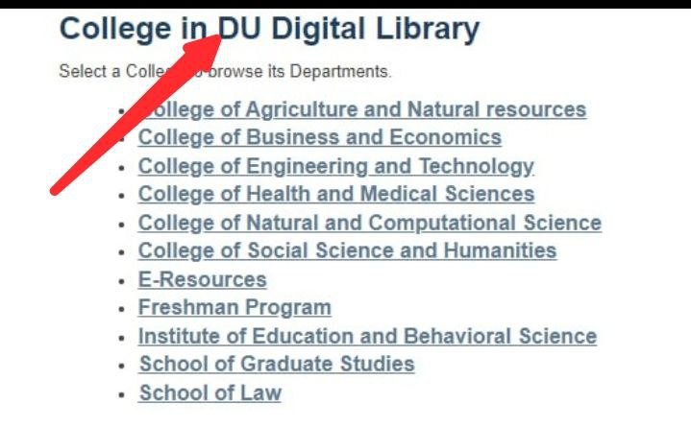
- Function: This icon could lead to a section listing affiliated colleges. Users might access resources specific to these colleges or explore collections related to academic institutions.
Browse Icon:
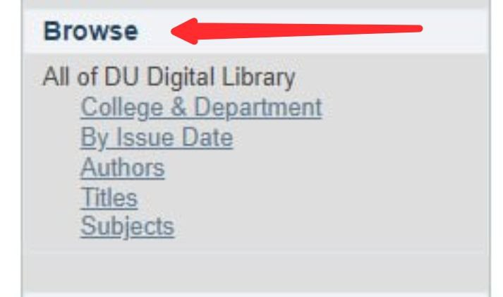
- Function: Allows users to explore the library’s content by categories or subjects. It might offer a structured view of different collections, genres, or topics, facilitating easy discovery of resources.
My Account Icon:
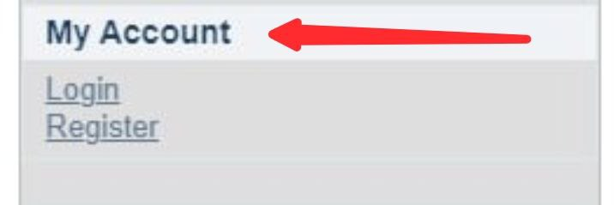
- Function: Provides access to the user’s personal account details. Users can view and manage their borrowing history, saved items, preferences, and other account-related settings.
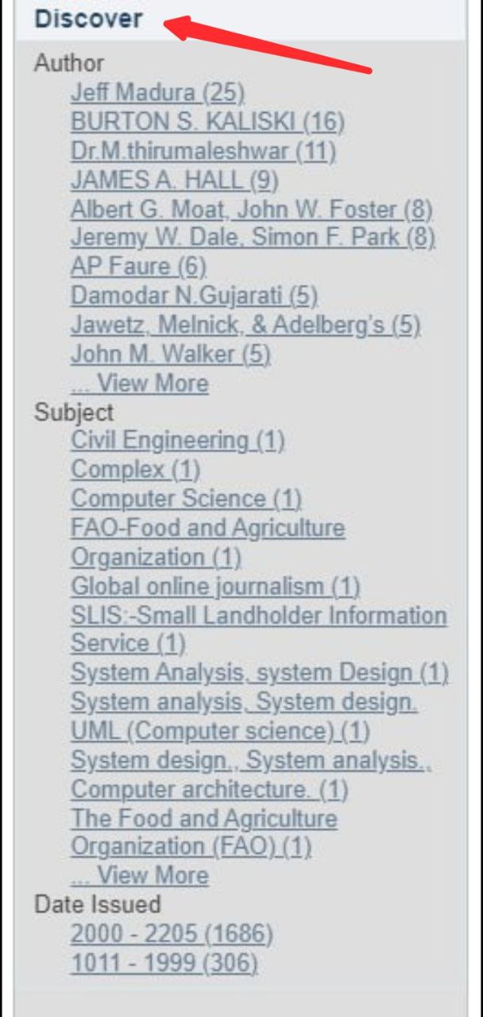
Discover Icon:

- Function: Highlights new or recommended resources. It often features curated collections, popular reads, or personalized suggestions based on the user's interests or previous activity.
- Searching for Resources
This is the process of finding information, documents, or other materials relevant to your needs. It involves using various tools and methods to locate resources efficiently.
- Basic Search:
This is the most straightforward method of searching. You enter keywords or phrases into a search bar and receive results that match or are closely related to those terms. Basic search is typically used when you have a general idea of what you're looking for.
- Advanced Search Options:
These options allow for more precise and refined searches. Advanced search typically involves using additional parameters such as date ranges, specific file types, or particular fields (e.g., title, author, subject). It helps narrow down results to find exactly what you need.
- Filtering and Sorting Results:
Filtering: This involves applying criteria to the search results to narrow down the list. Filters might include categories like publication date, author, relevance, or type of resource (e.g., books, articles, videos).
- Sorting: This involves arranging the search results in a particular order, such as by date, relevance, or alphabetical order. Sorting helps to prioritize the most useful or relevant results.
- Using Search Operators:
Search operators are special characters or commands used to refine searches. Common operators include:
  - Quotation Marks (""): Search for exact phrases (e.g., "climate change").
  - Plus, Sign (+): Include words that must be present (e.g., "sustainable + energy").
  - Minus Sign (-): Exclude words that are not relevant (e.g., "apple -fruit").
  - Asterisk (*): Use as a wildcard to represent any word or part of a word (e.g., "tech*").
  - OR: Search for either of the terms (e.g., "technology OR innovation").
- Downloading Resources
Here are the steps for downloading materials from a digital library:
- Navigate to Your College's Digital Library:
- Go to your college's digital library website or platform.
- Select Your College:
- If required, choose your college from a list or dropdown menu.
- Click on Your Department:
- Navigate to the section for your department or area of study.
- Find and Click on the Material:
- Browse or search for the specific material (book, article, etc.) you need and click on it.
- View/Open the Material:
- The material will open in the online reader or viewer within your browser.
- Download the Material
- Look for a download option or button if you wish to save the material to your device. Note that not all materials may be available for download; some may only be viewable online.
- Institutional Repository
The Institutional Repository serves as a platform for storing, managing, and disseminating the university’s research outputs, such as theses, dissertations, and academic publications.
NOTE: All rules and regulations listed in section A of the Digital Library apply to this Institutional Repository.

CHAPTER THREE

3.1 Library Employee Ethics and Member Complaint Management

3.1.1 Library Employee Responsibilities
- Employees have a duty to ensure that there are coordinated, carefully collected, structured and analyzed services that can satisfy the user's thirst for knowledge and information through reading, and to facilitate the conditions in which these services are accessible to the user without discrimination and division.
- The confidentiality of any library services or publications that patrons read, consult, reference, or borrow must be protected by employees.
- Employees are required to be free from bias and favoritism in both service delivery and interactions with consumers.
- Employees must ensure that their personal opinions and positions align with the organization's policy and adhere to the fundamental principles of their profession, avoiding any conflicts that may compromise professional integrity.
- Employees should be prohibited from engaging in rent-seeking behavior that compromises the interests of the institution and the service sector.
- The right to use library services should not be compromised due to differences in race, skin color, religion, ethnicity, or political affiliation.
- Employees have the responsibility to manage and administer the library so that its capabilities and services are utilized to their fullest potential.
- Employees have a duty to make the library comfortable, interesting, and safe for reading and studying.
- Employees have a duty to do what is necessary to ensure that library rules and regulations are observed and not violated.
- Library staff have the responsibility to fulfill their rights and obligations without bias or influence.

3.1.2 Library Employee Right
- The right to receive adequate and timely payment for work performed.
- The right to work in a setting that ensures physical and mental well-being, free from hazards or unsafe conditions.
- The right to be free from discrimination based on gender, race, religion, age, disability, or any other protected category.
- The right to work without being subjected to harassment, whether verbal, physical, or emotional.
- The right to be considered for promotions, raises, and career advancement opportunities based on merit and qualifications, without bias.
- The right to privacy regarding personal information, along with confidentiality in work-related matters.
- The right to attend training programs, workshops, and conferences to improve skills and advance in one's career.
- The right to be treated with respect and dignity by colleagues, supervisors, and library patrons.

3.2 Employees Disciplinary Measures

Light Disciplinary Measures
- Advise
    - Unfair & unbalanced service provision act.
    - Improper handling of library and information materials.
    - Negligent and careless handling, management, and utilization of library and information systems resources.
    - Improper and irregular handling and maintenance of statistical and other information.
    - Incomplete, incorrect, and untimely reporting behavior.
    - Late coming & early leave after and before working hours regularly.
    - Not managing irregularities or mismanaging of library furniture and equipment’s in the working environment of the library.
    - Being unconcerned and irresponsible to unlawful library and its resources utilization act.
    - Ineffective and inefficiency utilization of library resources.
    - Absence from work by insufficient reason without prior notice to the system.
    - Throwing of information resources during service.
    - Creating unfriendly service /working/ environment by arguing, quarrelling etc with staff &/or service user.
    - Miss shelving, displacing information resources etc intentionally.
    - Missing or hiding, or taking colleagues and /or users ID card, pocket, or other property intentionally and/or by negligence from the service area unlawfully.
    - Providing service by invalid ID card/pocket for user.
    - Uncooperativeness for additional activities or job assignment of the library system.
    - Insulting colleagues and /or users.
    - Being engaged on personal or social activities during working hours.
- Oral notice
    - Repeated act of (A)
- Written Notice
- Repeated acts of (A) & (B)

Heavy Disciplinary Measures
A. Appropriate Actions Will Be Taken in Accordance with the University's Disciplinary Regulations
- Any act of cheating up on the library system.
- Commission and /or omission of library rules and regulations violation.
- Creating and /or participating on illegal acts or mobs up on the system.
- Corrupting the finance of the library system.
- In effective ness and in efficiency on checkpoint activities.
- Abuse and misuse of library resources, rules and regulations
- Acting against the proper and smooth flow of library activities, other employees, users, etc.
- Missing overdue, loss, damage, service etc fines and charges by since unlawful attachment and by breaking the rules and regulations of the library systems.
- Working against the benefits of the library system.
- Violating the rules, regulations and laws of the library and the university system at large.
- Theft and cooperating on theft acts by some underground agreement with and /or from the library system, staff user and/or other external body.
- Damaging library resources.

3.3 Ways of Member Complaint Management
- Any user whose privacy or rights have been violated while using the library services may submit a complaint to the coordinator of the branch library.
- If the user who has submitted the complaint does not receive an appropriate response, he/she may submit the complaint to the campus library team leader. The decision of the director of the Library and information service shall be final.

CHAPTER FOUR

4.1 OTHER CONCERNS
There are no exceptions to these manual and regulations. However, the Library and information service, in consultation with the University's Academic Affairs, will oversee their implementation as needed.

4.2 Book Store
The Library is a department where various textbooks and continuing education modules are loaned to students on a semester basis. This department provides services not only to students but also to teachers. The following rules apply to both books issued for loan and books borrowed from the Library.
- A book store librarian sorts books by subject.
- Textbooks may be borrowed for a semester or a year, as needed.
- The book store user/student and staff/verifies the authenticity of the borrowed books when they return them.
- When a student, academic, or administrative employee leaves for the semester or leaves for education purpose, the book store librarian clerk certifies that he or she is free from debt and affixes his or her signature and the book store seal.
- Users can only borrow books from the book store if they have a valid university ID.
- If a user loses a borrowed textbook, he/she will be charged five times the price of the book.

4.3 Library usage hours
- Monday to Sunday, excluding holidays (3:00 AM to 12:00 PM, remaining hours are reserved for cleaning and bookkeeping).

4.4 Amendment of the law and its implementation period
- This manual shall come into effect only after it is approved by the top management.
- The library reserves the right to amend any of the bylaws.
- When a law is amended, it will be posted on the notice board, so users should read and implement it.
Written laws, regulations, and penalties will be implemented appropriately.

APPENDIX I
DILLA UNIVERSITY
DILLA UNIVERSITY LIBRARIES
ITEM LABELS
624.23
MEC
1996

CLASS NUMBER

CUTTER NUMBER

PUBLICATION YEAR

APPENDIX II
DILLA UNIVERSITY
DILLA UNIVERSITY LIBRARIES
CATALOGUE CARD
A) SUBJECT CARD
SOCIOLOGY
HM Tucker, William Thomas
330 The social context of economic behavior /by William
T87 Thomas Tucker.-2nded.-New York: McGraw –Hill, 1964.
1964 163p. Ill.-(Modern Management Series)
Includes bibliographies & index
ISBN: 0-4184-2572-8

B) AUTHOR CARD
Tucker, William Thomas
HM The social context of economic behavior /by William
330 Thomas Tucker.-2nded.-New York: McGraw –Hill, 1964.
T87 163p. Ill.-(Modern Management Series)
1964 Includes bibliographies & index
ISBN: 0-4184-2572-8
1. Sociology I. Title

C) TITLE CARD
The social context of economic behavior
HM Tucker, William Thomas
330 The social context of economic behavior /by William
T87 Thomas Tucker.-2nded.-New York: McGraw –Hill, 1964.
1964 163p. Ill.-(Modern Management Series)
Includes bibliographies & index
ISBN: 0-4184-2572-8

APPENDIX III
DILLA UNIVERSITY
DILLA UNIVERSITY LIBRARIES
BOOK SLIP
CALL N^{O}: _________________________
AUTHOR: _________________________
TITLE: ____________________________
ACC.N^{O}: __________________________

DATE DUE | DATE DUE

APPENDIX IV
DILLA UNIVERSITY
DILLA UNIVERSITY LIBRARIES
BOOK POCKET

AUTHOR
TITLE
CALL N^{O}

ED.
VOL.
C/ACC.N^{O}:

APPENDIX V
DILLA UNIVERSITY
DILLA UNIVERSITY LIBRARIES
Reserve or not Allowed out of Library use Information resource loan request format
Reserve __ Periodicals __ Documentation collection __ Electronic databases __AV materials
This is to certify that: -
Mr/Mrs _____________________________________ ID Nº _______________ whose occupation is ________________________________ requires borrowing DU Libraries material (reserved or materials not allowed out of library use). Call nº ____________________________,
Title ________________________________________________________________________, Author _____________________________________________, Ed. _________________, & Accession nº ___________________________ to offer a course entitled _____________________________________________, course nº _______________, academic year _______________, for semester _________.
Faculty & department/School ___________________________________________
Department/School Head name ________________________ Sign. __________ Date__________
To be filled by the library
I [branch library circulation Section Head name & sign] certify that she/he is not borrowed the specified same material currently.
With regards
[Sign. of branch library head (BHL)]
[Name of BHL]
[Titer of branch library]

APPENDIX VI
DILLA UNIVERSITY
DILLA UNIVERSITY LIBRARIES
INFORMATION RESOURCES RESERVE
APPLICATION FORMAT
Faculty: _____________________Department/School: __________________________
Name of Instructor: ______________________________________
Course Title: ____________________________________ Course Nº: ______________
Duration: - Semester: ____ Year: _____ [Put (X) Mark on Space Provided]
Date the Sem. Begin: ______________ Date the Sem. End: ___________
Bibliographic Details of Information Resources Required To Be Reserved
N^{O} | CALL N^{O} | AUTHOR | TITLE | ED | PUBLICATION DATE | REMARK
Total Nº of Students Who Take the Course: _________
Confirmation: Faculty Head Dept. Head
Name: _________________ __________________
Sign : _________________ __________________
Date: _________________ __________________
To Be Filled By the Library
Total Nº of Information Resources Owned By the Library: ____________
Nº of Materials Currently Available: ____________________
Confirmed By:
Name _____________________ Sign. ______________ Date: __________
With Regards!

Note (If any): ___________________________________________________________________________________________________________________________________________________________________________
APPENDIX VIII
DILLA UNIVERSITY
DILLA UNIVERSITY LIBRARIES
RESERVE LOAN CARD
CALL N^{O}: _____________________________________________
AUTHOR: _____________________________________________
TITLE: ________________________________________________
ED._____ YEAR OF PUBLICATION _______________________
COPY/ACC. N^{O}: _______________________________________

DATE | USER’S ID N^{O} | TIME  ISSUED | RETURN  TIME | USER’S  SIGN.

APPENDIX IX
DILLA UNIVERSITY
DILLA UNIVERSITY LIBRARIES
PAY BILL
Material Status: Res/Stack/Ref/Per/Doc/Database/Av
Bibliografic Info: Call Nº: ___________________, Acc. Nº: ________________
User’s Info: Name: ___________________________, Id Nº: ___________________
Dept/Sch: _____________________, Date: _______, Status: ________
Reason:
Over Due Loss
Time/Date Due: ______________________ _________________
Time/Date Return: ______________________ _________________
Difference: ______________________ _________________
Pay Amount/Price: ______________________ _________________
Prepared By:
Name: ________________________, Sign: ___________, Date: _______, Shift: ____

-----------------------------------------------------------------------------------------------------------------------------

Date | Call Nº | Acc. Nº | Name | Id Nº | Dept/Sch. | Status | Pay Amount | Remark
Prepared By:
Name: ________________________, Sign: ___________, Date: _______, Shift: _____

APPENDIX X
DILLA UNIVERSITY
DILLA UNIVERSITY LIBRARIES
Membership card
Name ----------------------------------------- I.D--------------------
Dept/\unit----------------------------------------Year---------------------
Faculty Member Student Staff Telephone office --------------
I agree to the abide by the rules and regulations of Dilla University Library
I have received-------------------------
Book Pockets
Date: --------------------------------
Signed: -----------------------------------
Serial No ---------------------------

APPENDIX XI
DILLA UNIVERSITY
DILLA UNIVERSITY LIBRARIES
INTERLIBRARY LOAN FORMAT
Name of users________________________________
Dept./Section/unit_____________________________
Title of books/Article requested_________________________________
Date the request was made_______________________________
Library from which the Item is borrowed__________________________
Date Received___________________________________________
Date Due______________________________________________
Date the item is Returned__________________________________
Remark____________________________________________

APPENDIX XII
DILLA UNIVERSITY
DILLA UNIVERSITY LIBRARIES
Temporary ID Card
Ref. no___________
Date _____________
Dilla University
Dilla University Libraries
Temporary ID Card
This is to Certifay That Name _________________________ID No ___________________is provided that She/He has Right to use our System from Date __________to ____________.
Thank You!
[Sign. & Seal]

APPENDIX XIII
DILLA UNIVERSITY
DILLA UNIVERSITY LIBRARIES
Users ID Card/Pocket Missing Assurance Slip
User Info Approved By
Name____________________ Name: _______________________
ID no ____________________ Branch Library _________________
Fac. ______________________ Shift ________ Date __________ Sign _____________
Dept./Sch. _________________
Shift ______________________
Desk ______________________

APPENDIX XIV
DILLA UNIVERSITY
DILLA UNIVERSITY LIBRARIES
Lost/Damaged Library Items Report Format
Branch library________________________
N^{O} | CALL  N^{O} | ACCESSION  N^{O} | TITLE | AUTHOR | YEAR | ISBN | ED. | QTY. | UNIT  PRICE |  | TOTAL PRICE |  | REM
 |  |  |  |  |  |  |  |  | Br. | C | Br. | C

APPENDIX XV
DILLA UNIVERSITY
DILLA UNIVERSITY LIBRARIES
Acquisition Suggestion Form
___________________ Library
I Would Like to Recommend You To Subscribe The Following Materials
N^{O} | TITLE | AUTHOR/ EDITOR | YEAR OF PUB | ISBN/ISSN | ED. | PRICE |  | REM
 |  |  |  |  |  | Br | C
Note: Fill Out The Form As Complete As Possible. Avoid Abbreviations.

APPENDIX XVI
DILLA UNIVERSITY
DILLA UNIVERSITY LIBRARIES
BINDING REQUIEST FORMAT
N^{O} | CALL  N^{O} | ACCESSION  N^{O} | TITLE | AUTHOR | YEAR OF PUB | ISBN/ISSN | ED. | QTY. | STATUS | REASON | REM

APPENDIX XVI
DILLA UNIVERSITY
DILLA UNIVERSITY LIBRARIES
PUBLICATION TRANSFER FORMAT

N^{O} | CALL  N^{O} | ACCESSION  N^{O} | TITLE | AUTHOR | YOP | ISBN/ISSN | ED. | QTY. | REM

Reason For Transfer: _______________________________________________________

Transferred From Transferred To
Name __________________________________ Name __________________________
Title ____________________________________ Title _________________________
Branch Library_________________________ Branch Library_________________
Section/Desk_________________________ Section/Desk____________________
Sign_________________________ Sign_________________________
Date_________________________ Date_________________________
Witnesses
1.___________________
2.___________________
3.___________________

APPENDIX XVII
DILLA UNIVERSITY
DILLA UNIVERSITY LIBRARIES
General Users’ Statistics (At Check Point)
Time | Male | Female | Prepared by | Signature | Remark
8am - 9am
9am - 10am
10am -11am
11am -12am
12am -1pm
1pm - 2pm
2pm - 3pm
3pm - 4pm
4pm- 5pm
5pm- 6pm
6pm- 7pm
7pm- 8pm
8pm- 9pm
9pm- 10pm
10pm-11pm
11pm-12pm
12pm-1am
1am- 2am
2am-3am
3am-4am
4am-5am
5am-6am

APPENDIX XVIII
DILLA UNIVERSITY
DILLA UNIVERSITY LIBRARIES
REFERNCE SERVICES INQUIRY FORMAT
Branch Library: ___________________________
Requested Information__________________________________________________________
______________________________________________________________________________
__________________________________________________________________________________________________________________________________________________________________________________________________________________________________________
User’s Name: _______________________________
Id Nº: _______________________________________
Year: _______ Faculty: _____________________
Dept/School: _______________
Status: (Put (X) Mark To Indicate User’s status On The Space Provided)
__Academic Staff __Administrative Staff
__Reg. Student __Ext. Student __Others
By The Librarian
Date Of Request: ____________
Time & Date Of Appointment: _____________
Remark (If Any): ______________[Here You Can Specify The Source (S) Of Information] ________________________________________________________________________________________________________________________________________________________________________________________________________.
[Signiture Of Ref. Librarian]
[Name Of Ref. Librarian]

APPENDIX XIX
DILLA UNIVERSITY
DILLA UNIVERSITY LIBRARIES
CALL IN SLIP/REMINDING NOTICE
To: _____________________________________ Id Nº: ________________________
Faculty/Office: ________________________ Dept. /School: _____________
Status: _________________________________.
Please Return The Material You Borrowed From ____________________________
Library On Date _____________ Entitled ____________________________________
Author _______________________________ Call Nº ___________________ Copy/Accesssion Nº____________ Ed. _____ Year Of Publication ___________Till Date _________.
Thank You.

APPENDIX XX
DILLA UNIVERSITY
DILLA UNIVERSITY LIBRARIES
Text Book Delivery Desk
To: University Libraries:
From: _____________________________
Subject: Text Book Delivery Request
Faculty: ____________________________Department/School: __________________________
Name of Instructor: ______________________________________
Course Title: ____________________________________ Course Nº: ______________
Duration: - Semester: ____ Year: _____ [Put (X) Mark on Space Provided]
Date the Sem. Begin: ______________ Date the Sem. End: ___________
Bibliographic Details of Information Resources Required To Be delivered as textbook
N^{O} | CALL N^{O} | AUTHOR | TITLE | ED | PUBLICATION DATE | REM
Total Nº of Students Who Take the Course: _________
Confirmation: Faculty Head Dept. Head
Name: _________________ __________________
Sign: _________________ __________________
Date: _________________ __________________
To Be Filled By the Library
Total Nº of Information Resources Owned By the Library: ____________
Nº of Materials Currently Available: ____________________
Confirmed By: Name _____________________ Sign. ______________ Date: __________
With Regards!
NOTE: Please attach the list of students who are eligible to take the textbook.
APPENDIX XX
DILLA UNIVERSITY
DILLA UNIVERSITY LIBRARIES
TEXTBOOK LOAN SCHEDULE
Dilla University Libraries textbook desk will deliver textbooks to legible users according to the following schedule:

S.N^{O} | Course Title | Course Nº | Title of the Book | Author | Instructor | Date | Remark

NOTE:
- All legible applicants should come up with
  - Currently renewed ID card , &
  - Registration slip
- Service hours:
Monday – Friday
8:00 am - 4:45 pm
- No one will be served out of the schedule.

APPENDIX XX
DILLA UNIVERSITY
DILLA UNIVERSITY LIBRARIES
TEXT BOOK LOAN CARD
Id Nº: _____________ Year: _____________ Name: ___________________
Faculty: _______ Dept. _______________________
Course No | Date Issued | Author | Title | C/Acc.No
Note:
Book should be returned at the end of each semester irrespective of their usage for the subsequent semester. if the books are required for the semester following it will be reissued.
Lost book can be replaced by brad new ones which are exactly identical or be paid the original price.

Reference

